University of Hertfordshire

School of Computer Science

BSc Computer Science

Module: Mobile Computing

Coursework

Usability Report

Daniel Puscas

Level 6

Academic Year 2019-2020

Table of Contents

1.0 Introduction 2

1.1 Effectiveness 2

1.2 Efficiency 3

1.3 User Satisfaction 4

1.3 Conclusions 5

1.4 References 5

# 1.0 Introduction

The project for this course is a mobile game designed for Apple’s smartphones. This game is based around the popular Angry Birds game, the program consists of three main objects the aim target which shoots balls which is the second main object and the birds which are the target. The way it works is if a ball hits a bird then the bird disappears from the screen.

Within this report I will be analysing the usability of this app for the purpose to check how it performs when launched. This report will be broken down into three main sections based on usability’s core characteristics, Effectiveness, Efficiency and Satisfaction. Effectiveness being checking if the success of execution, Efficiency the time in which the user and/or the program takes to complete a task and Satisfaction which checks for the impression the program leaves to the user, will the user re-use this application?

## 1.1 Effectiveness

Effectiveness is part of usability checks how tasks are completed within the application. This normally refers to the degree in which errors are avoided and tasks are completed successfully. This application has not been tested outside the development phase for example this application did not run tests like Beta tests.

For this application I have noticed that the same target appears twice or more eg figure1

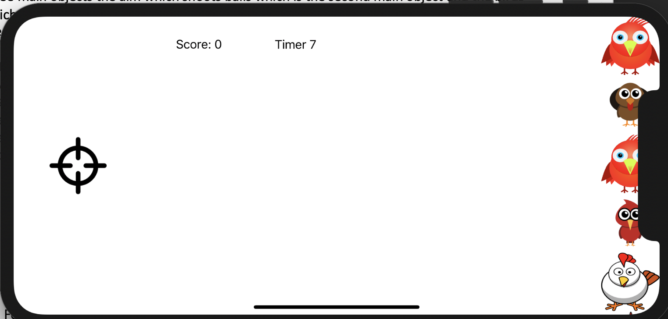

[Figure1 Screenshot Of the application running when the fault appears]

In [figure 1] shows that the task completes as birds appear on the screen, but the same bird appears twice this is due to the effectiveness of the code. This could be fixed but due to the time limit the product could meet the target.

This application completes the task to display targets on the screen which in this case are birds but as shown in [figure1] for the iPhone models which contain a notch at the top off the screen birds will be cut out as there is no screen. The app successfully completes this task as there are no operational errors, but minor flaws appear on the user interface which could affect user satisfaction.

For the usability’s aspect of effectiveness this application does not contain major operational flaws, minor flaws which discussed above.

## 1.2 Efficiency

Efficiency looks at the rate in which the interface takes to complete a task. For the application designed for this course efficiency is important as if the game takes a long period of time to load the user satisfaction and effectiveness decreases. There are many ways to check user satisfaction and effectiveness and efficiency one way is through user surveys, user activity, uninstall rates and more.

Within this phase which is the usability analysis before deployment. This game does not contain a vast number of screens and objects which affect run time speed, but it has to run smoothly and with minimal load time. The transition between screens is quick and efficient



[Figure2 Screenshot Of the application running the second screen]

## 1.3 User Satisfaction

User Satisfaction looks at how the user interacts with the system if is a good interaction or not depends if he/she will use the application again. There are targets which applications are required to hit in order for it to be satisfactory to the user the key ones are Simple navigation, Clear Content, Minimize the steps number and reduce Scrolling.

Simple Navigation is crucial as if the program is hard to navigate through users will lose interest. For app designed within this course the navigation is too simple which also creates confusion as the user is not instructed what to do or what to expect the program to do, at this point users when they load this application jumps straight into the game as shown In Figure[1]. This creates confusion especially for new users who never used this application. For this project the optimal solution would be to have another screen as a start screen as this will prepare the user to start the game. This could be achieved with an extension on the time frame of the project

Clear Content its important in mobile app development as if users do not grasp the procedure of which the application is running, they will not be able to use the application. Also having insufficient content will produce problems which in this case it has due to not having an content screen to inform the user on how to start the game and instruct the user how to use the app.

Another factor is user engagement in game development this is very important as an app should keep the user engaged and give the user the desire to want to play the game again. Due to time constraints I have not been able to increase the scope of this app to include more features that will keep the user more engaged. Adding levels will improve this application as physiologically is proven that a user will want to achieve a higher level and improve their skills. Adding a reward function will improve this application’s user engagement as it will give the user positive feedback.

## 

## 1.3 Conclusions

This project after the usability analysis concludes that its operational and efficiency are on point the problems lay on the area of user satisfaction especially navigation and user engagement functions to improve the following could be created with a time extension before launching the product.

## 1.4 References

Medium, 2019, How to Measure the Effectiveness of a Mobile Application?,[Online] Available at: <https://medium.com/swlh/how-to-measure-the-effectiveness-of-a-mobile-application-23c29c6722cd>  Accessed on [11/01/2020]

ClearBridge, 2018, 7 Best Practices to Overcome Mobile App Usability Issues?,[Online] Available at: <https://clearbridgemobile.com/7-best-practices-to-overcome-mobile-app-usability-issues/>  Accessed on [11/01/2020]

UsabilityIfirst, 2015 Glossary » effectiveness, [Online] Available at: <https://www.usabilityfirst.com/glossary/effectiveness/index.html>   Accessed on [11/01/2020]

UsabilityIfirst, 2015 Glossary » efficiency, [Online] Available at:

<https://www.usabilityfirst.com/glossary/efficiency/>  Accessed on [11/01/2020]

GetSocial, 2019, Is Gamification the Only Way for Apps to Survive?, [Online] Available at:

<https://blog.getsocial.im/is-gamification-the-only-way-for-apps-to-survive/> Accessed on [11/01/2020]